Minimax in Arbitrarily board-size of Tic-tac-toe

By: Daniel Guzman

CSU Chico State

3/25/2022

Abstract

This report goes over my discoveries of the General concept of the Minimax algorithm along with the implementations within games which, such an example that’s covered within this report, being the board game Tic-Tac-Toe of arbitrary board size, i.e., 3x3, 4x4, …

The Minimax algorithm developed and proven by John Von Neumann is considered the basis on the subject of Game Theory and for developing an A.I model / CPU for any turn based game, where the objective of the A.I opponent is to Minimize or Maximize the gains of its decisions without explicitly knowing the next decision of other players playing the game. The general idea of The Minimax algorithm is that it is designed in a worst-case approach, such that in order to determine the best action to take against all other players in the game, the algorithm will check / calculate the gains of all possible actions of the other players to determine which move to take.

An example would be, say that you are playing a game of chess with an A.I that is modeled by the Minimax algorithm, in this scenario your objectives would be to play the game normally and determine which moves would be best to beat the opponent, on the other hand, the A.I’s objectives is to simply calculate all possible moves that you will choose and determine which moves will minimize your gains in winning the game.

The way we should think about this algorithm conceptually is as a binary tree where the root is where we begin and recursively go down to the leafs where, from the leafs at depth = n, we then backtrack while eveculating each node for their heuristic value.

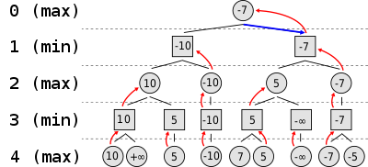

Reference

<https://www.computerhistory.org/chess/the-minimax-algorithm-and-alphabeta-pruning/>

<https://en.wikipedia.org/wiki/Minimax>

<https://cs.stanford.edu/people/eroberts/courses/soco/projects/1998-99/game-theory/Minimax.html>